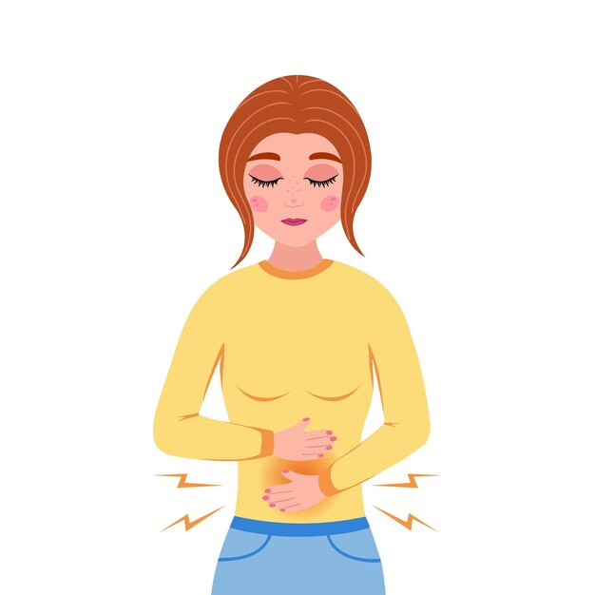

|  |  |  |
| --- | --- | --- |
| Patient Information  **Proton Pump Inhibitors (PPIs)** |  |  |
| Proton pump inhibitors such as Omeprazole, Lansoprazole, Pantoprazole, Rabeprazole, and Esomeprazole are very effective medicines that reduce the stomach's acid. However, if used long–term they can cause unwanted side effects. Therefore, it is important that this treatment is reviewed regularly, and the dose reduced or stopped when appropriate. |  |  |

**Stepping down or reducing your PPI medication**

**What is acid reflux or indigestion (dyspepsia) and heartburn?**

Indigestion (also known as dyspepsia), acid reflux, and heartburn may occur when stomach acid meets the food pipe (oesophagus) or stomach. Symptoms may include pain and/or a burning sensation in the chest wall, bloating, burping, feeling nauseous or vomiting.

**What are proton pump inhibitors (PPIs)?**

Proton pump inhibitors are a class of medication given to patients with dyspepsia, acid reflux or heartburn. They help reduce the amount of stomach acid production. Reducing stomach acid allows the body time to heal any inflammation or irritation in the oesophagus or stomach.

**Why does my PPI need to be regularly reviewed?**

Current recommendations suggest that most patients given PPIs should only use them for a short time unless their doctor or nurse has advised otherwise. PPIs are normally started on a higher dose, which may be reduced to a lower (maintenance) dose and then reviewed regularly by your clinician, stopping, or taking as needed, if deemed appropriate.

**What are the potential risks if PPIs are taken long-term?**

PPI use is considered to increase the risks of developing or masking several conditions including:

• Clostridium difficile, a gut infection causing severe diarrhea

• Masking gastric and stomach cancer

• Increasing risk of pneumonia

• Potentially reducing the body’s magnesium level.

Prescribing PPIs for the shortest time and lowest effective dose are important. They should be reviewed regularly, as your healthcare professional deems appropriate.

**Why should I stop my PPI slowly?**

Research has found that some people taking PPIs for more than 2 months can produce more acid (rebound acid) to compensate for these medications. Production of acid can be more than 80% higher than when they first started a PPI! This may mean your symptoms worsen when you try to stop.

**How do I stop or reduce my PPI?**

• If you are currently taking a higher dose, aim to reduce to a lower dose daily for 1 month.

• For 2-4 weeks take your PPI alternate days. If you develop any dyspepsia, heartburn, or acid reflux you may need to take an over-the-counter indigestion remedy, for example Peptac. Please discuss this with your doctor, nurse, or pharmacist

• Reduce your medication further by taking every 3 days for 2-4 weeks, then every 4 days until you can stop.

Indigestion, acid reflux, or heartburn symptoms should improve within 2 weeks of stopping PPI. If you have any concerns about your symptoms or if they have not improved, please contact your doctor or other healthcare professional.

**LIFESTYLE CHANGES YOU CAN MAKE TO IMPROVE YOUR SYMPTOMS**

♦ Reduce or stop smoking.

♦ Eat meals at regular times and in moderation; have your last meal at least 3 - 4 hours before bedtime.

♦ Raise the head of the bed by 15 - 20cm, e.g., with books under the legs of the bed.

♦ Reduce fat in your diet and try to lose weight if you are overweight.

♦ Reduce or avoid alcohol.

♦ Avoid foods that you associate with your symptoms. These may include:

- spicy foods,

- caffeine-containing drinks (chocolate, coffee, cola),

- acidic food or drinks.

♦ Avoid tight belts or clothing.

♦ Avoid bending down or lying flat after a meal.

Adapted From: AWTTC “Safe Use of Proton Pump Inhibitors”, NHS West Suffolk “PPI Information leaflet”