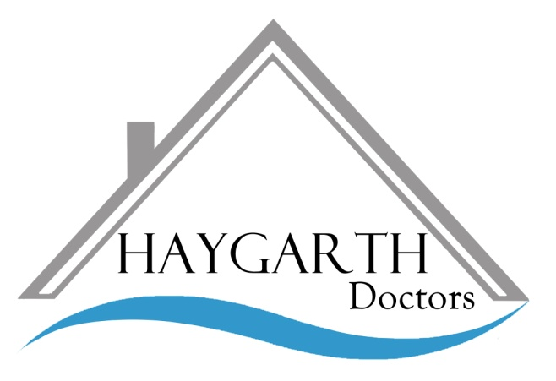

Version 07.2021

Access to Medical

Records under the

Data Protection Act

**HAYGARTH**

**DOCTORS**

**TEACHING PRACTICE**

We need to hold personal information about you on our computer system and in paper records to help us to look after your health needs. Your doctor is responsible for their accuracy and safekeeping. Please help to keep your record up to date by informing us of any changes to your circumstances.

These records may include :

* Basic details about you such as address, date of birth, next of kin
* Contact we have had with you such as clinical visits
* Notes and reports about your health
* Details and records about your treatment and care
* Results of x-rays, laboratory tests
* Relevant information about people who care for you and know you well, such as health professionals and relatives

It is good practice for people in the NHS who provide care to :

* Discuss and agree with you what they are going to record about you
* Show you what they have recorded about you, if you ask

**Making a Subject Access Request (SAR)**

The Data Protection Act gives every living person (or authorised representative) the right to apply for access to their health records.

A request for your medical records held by Haygarth Doctors must be made in writing either by letter or using a ‘Request for Access to Medical Records’ form available from Reception at The Medical Centres in Hay-on-Wye and Talgarth. (Please contact the practice for alternative methods of access if you are unable to make a request in writing).

**Making a Subject Access Request (SAR)**

**continued ….**

* Ensure that the form is fully completed and return it to The Medical Centre. It would be helpful if you could provide details of the time-periods and aspects of your health record you require (this is optional but may help save practice time and resources).
* Under the Data Protection Act you will not normally be charged a fee to view your health records or to be provided with a copy unless the request is judged to be unfounded or excessive.
* In the event that a request is deemed to be unfounded or excessive, a

fee will be charged based on the administrative cost of providing the information.

* Once the practice has all the required information, and fee where relevant, your request should be fulfilled within one month. In exceptional circum-stances where it is not possible to comply within this period, you will be informed of the delay. We will provide you with a timescale of when the information will be available, which will be no more than three months after the request was made.
* Where possible we would ask you to personally collect the copy of your records.
* There are no facilities for immediate access.

**Tel. 01497 822100**

**www.hay-garth.co.uk**

The Medical Centre

Hay Road

Talgarth

Powys, LD3 0AW

The Medical Centre

Forest Road

Hay-on-Wye

Hereford, HR3 5DS

**Name of the ‘Data Protection Officer**

**as a Service’**

Digital Health and Care Wales (DHCW)

Information Governance

Data Protection Officer Support Service

4th Floor, Tŷ Glan-yr-Afon, 21 Cowbridge Road East, Cardiff CF11 9AD

E-mail : DHCWGMPDPO@wales.nhs.uk

**Complaints**

If you have a complaint about any aspect of your application to obtain access to your health records, you should first discuss this with the Practice Manager (by appointment).

All complaints will be acknowledged within 2 working days and a full response will be provided within

28 working days.

If you are unhappy with the response, you can then contact the Information Commissioners Office (responsible for governing Data Protection compliance) –

Information Commissioners Office –

Wales

2nd Floor, Churchill House

Churchill Way

Cardiff CF10 2HH

Tel. 0330 414 6421

[wales@ico.org.uk](mailto:wales@ico.org.uk)

Subject Access Request so they can make an informed decision on whether they wish to exercise their rights under the Data Protection Act

**Access to a Deceased Patient’s Medical Records**

For deceased persons, applications are made under sections of the 1990 Access to Health Records Act. These sections provide the right of access to the health records of deceased individuals for their personal representative and others having a claim under the estate of the deceased.

Access shall not be given (even to the personal representative) to any part of the record which would disclose information which is not relevant to any claim which may arise out of the patient’s death.

After a person has died, their GP health records are passed to *NHS Wales Shared Services Partnership*, so they can be stored. To access the GP records, apply to the Health Records Request Department. Please call 01495 300730 or write to Health Records Requests Department, NHS Wales Shared Services Partnership, Cwmbran House, Mamhilad Park Estate, Pontypool, NP4 0XS.

GP records are generally retained for 10 years after the patient's death before they are destroyed.

**Making a Subject Access Request (SAR) continued ….**

**Exemptions**

In some circumstances, the Act permits the withholding of information held in your health records. These rare cases are :

* Where it has been judged that supplying the information is likely to cause serious harm to the physical or mental health or condition of you, or any other person or;
* Where providing access would disclose information relating to or provided by a third person who had not consented to the disclosure. This exemption does not apply where that third person is a clinician involved in your care

If you are using an authorised represen- tative, you need to be aware that in doing so, they may gain access to all health records concerning you, which may not

all be relevant. If this is a concern, you should inform your representative of what information you wish them to specifically request when they are applying for access.

GP’s have ethical obligations around how patient records are shared, and will explain to patients on request, in broad terms, the implications of making a